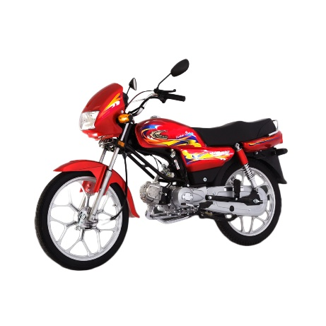

United 100cc Motorcycle Alloy Wheel (Karachi Olnly)

Product details of United 100cc Motorcycle Alloy Wheel (Karachi Olnly)

* Engine Type 4-Stroke OHC Single Cylinder cooled by Air
* Displacement 97cc
* Compression 8.1:1
* Front Brake Drum Mechanical
* Rear Brake Drum mechanical
* Transmission 4-Speed
* Starting System Arm Assy Kick
* Fuel Tank Capacity 8.5 Litre
* Tyre Front 2.50-18/4PR
* Tyre Rear 2.75-18/6PR
* Battery12 Volt
* Engine Oil0.8 Litre